Module Six: Test Coverage Summary Report
Khem Raj Khatiwada
Southern New Hampshire University
CS-320-19695-M01 Software Test, Automation
Karl Lewis
02/14/2026

Test Coverage Summary Report
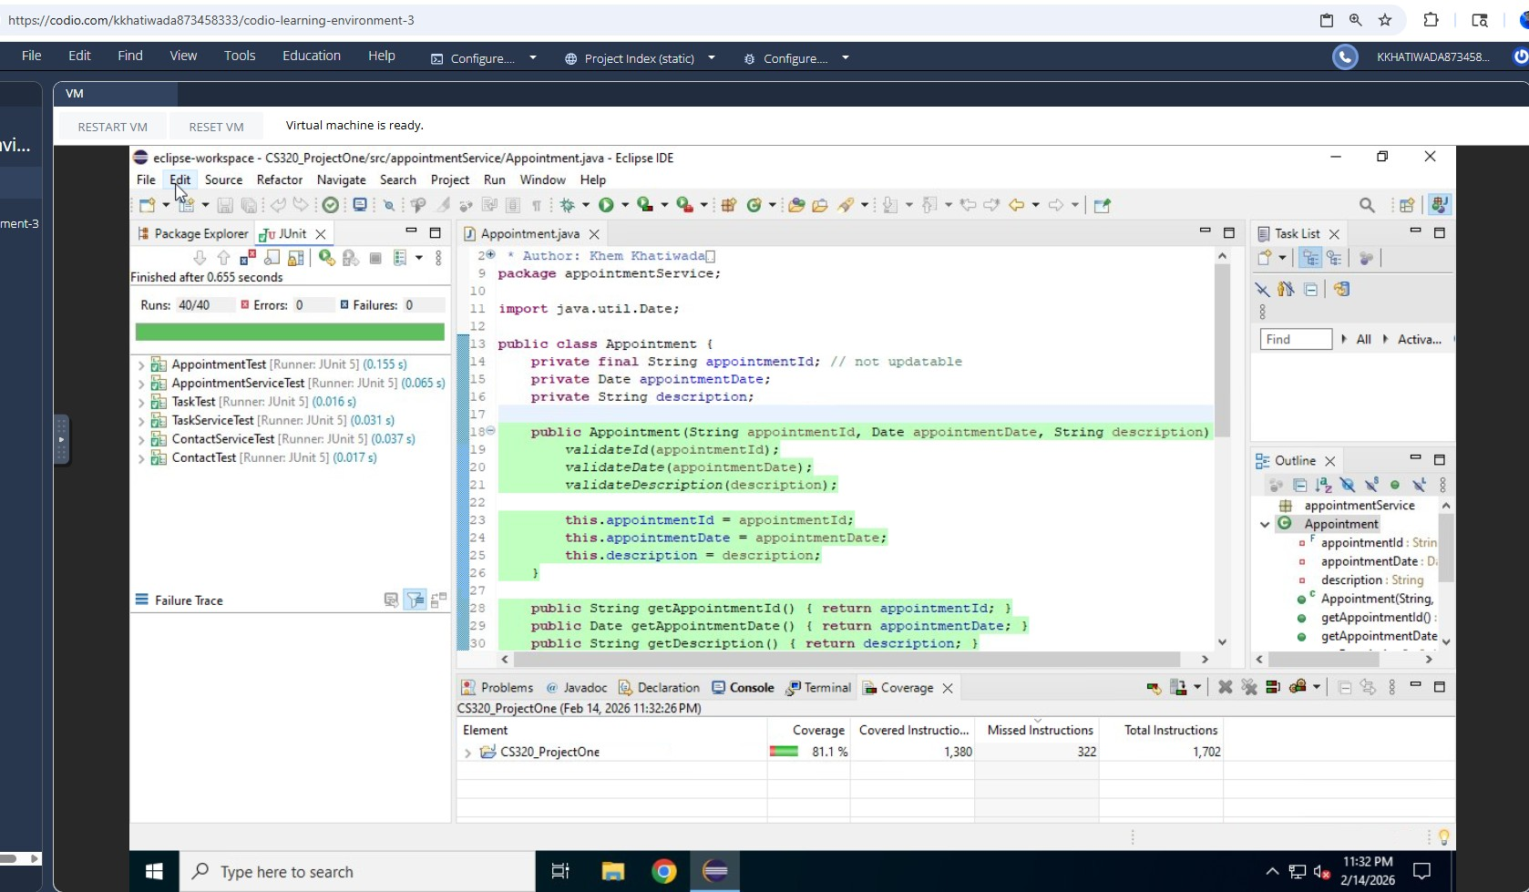
Figure 1 Junit coverage
Unit testing was performed on the Contact, Task, and Appointment services to verify that each feature met the specified software requirements. JUnit 5 test cases were written to validate object creation, field constraints, update operations, and deletion behavior. Boundary value and negative testing strategies were applied to ensure that invalid inputs, such as null values, excessively long strings, past appointment dates, and duplicate identifiers, correctly triggered exceptions.
The overall code coverage achieved for the project was 81.1% of total instructions, with 1,380 instructions covered and 322 instructions missing out of 1,702 total instructions. This coverage level indicates that most of the functional logic and validation paths were successfully exercised by the unit tests. Remaining uncovered instructions are primarily associated with less-frequently executed branches or defensive validation paths that could be addressed with additional edge case tests.
Overall, the testing approach demonstrates effective verification of requirements, appropriate use of automated unit testing, and strong alignment with software quality assurance practices. Additional targeted test cases could further increase coverage and improve confidence in long-term maintainability.

